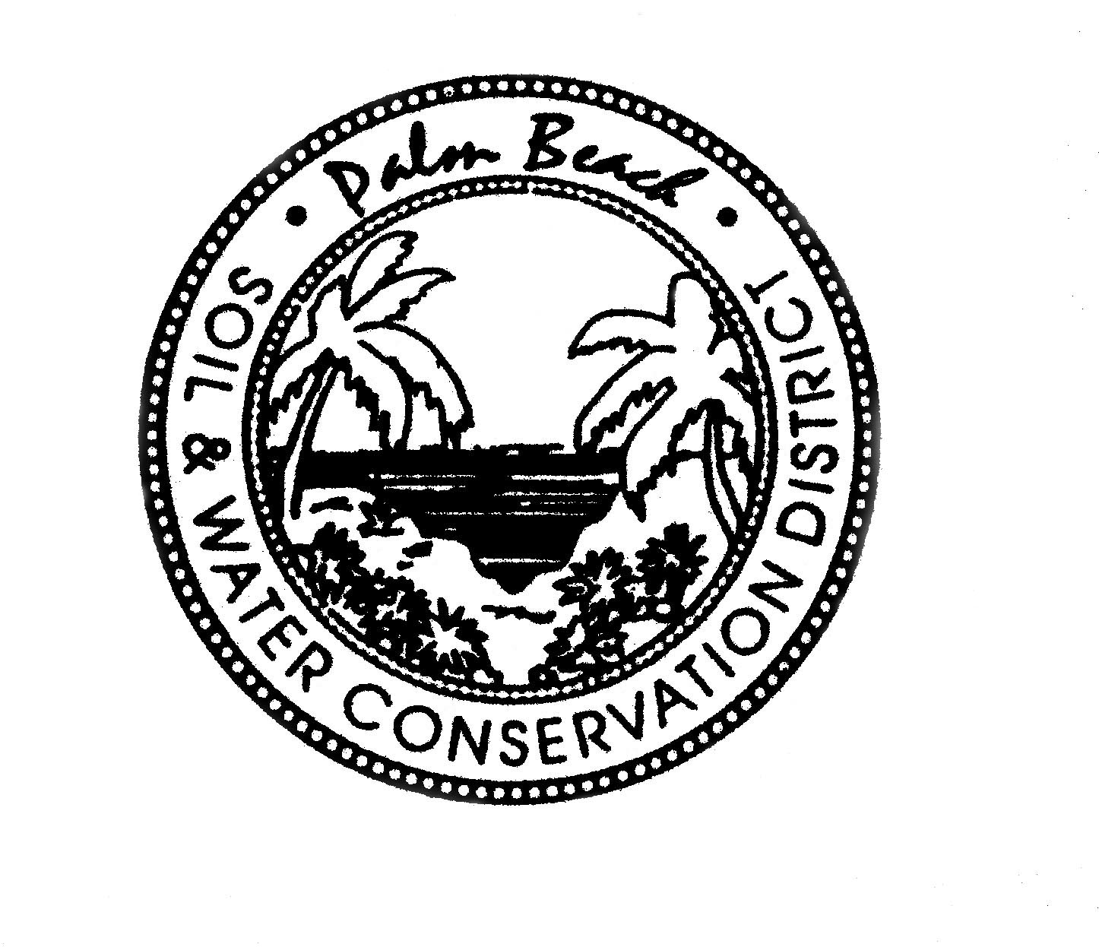

AGENDA

PALM BEACH SOIL & WATER CONSERVATION DISTRICT
BOARD OF GOVERNING SUPERVISORS MEETING
Vista Center 2300 N. Jog Road, WPB 33411
February 22, 2024 at 1:30 PM

Part of this meeting may be conducted as a video or teleconference in order to permit maximum participation of Board members (Section, 120.54(5)(b)2). The Board may take official action at this meeting on any item appearing on this agenda and on any item that is added to this agenda as a result of a change to the agenda approved by the presiding officer of the meeting pursuant to Section 120.525, Florida Statutes. The order of items appearing on the agenda is subject to change during the meeting and is at the discretion of the presiding officer.

1. CALL TO ORDER
A Roll Call
B Invocation
C Pledge of Allegiance

2. *AGENDA APPROVAL

3. SECRETARY’S REPORT
*Approval of the January Meeting Minutes

- TREASURER’S REPORT

*Certificate of Deposit

- STAFF REPORTS
A David DeMaio
B Laura Bloom
C Rosa Reyes
D Robert Perez

- USDA/NRCS UPDATE – Jeff Schmidt, Assistant State Conservationist – FO, Area 4

NEW BUSINESS

OLD BUSINESS
- House Bill 1075 & Senate Bill 1772 Update

DISCUSSION ITEMS

PUBLIC COMMENTS

ADJOURNMENT
*DENOTES ACTION ITEM

