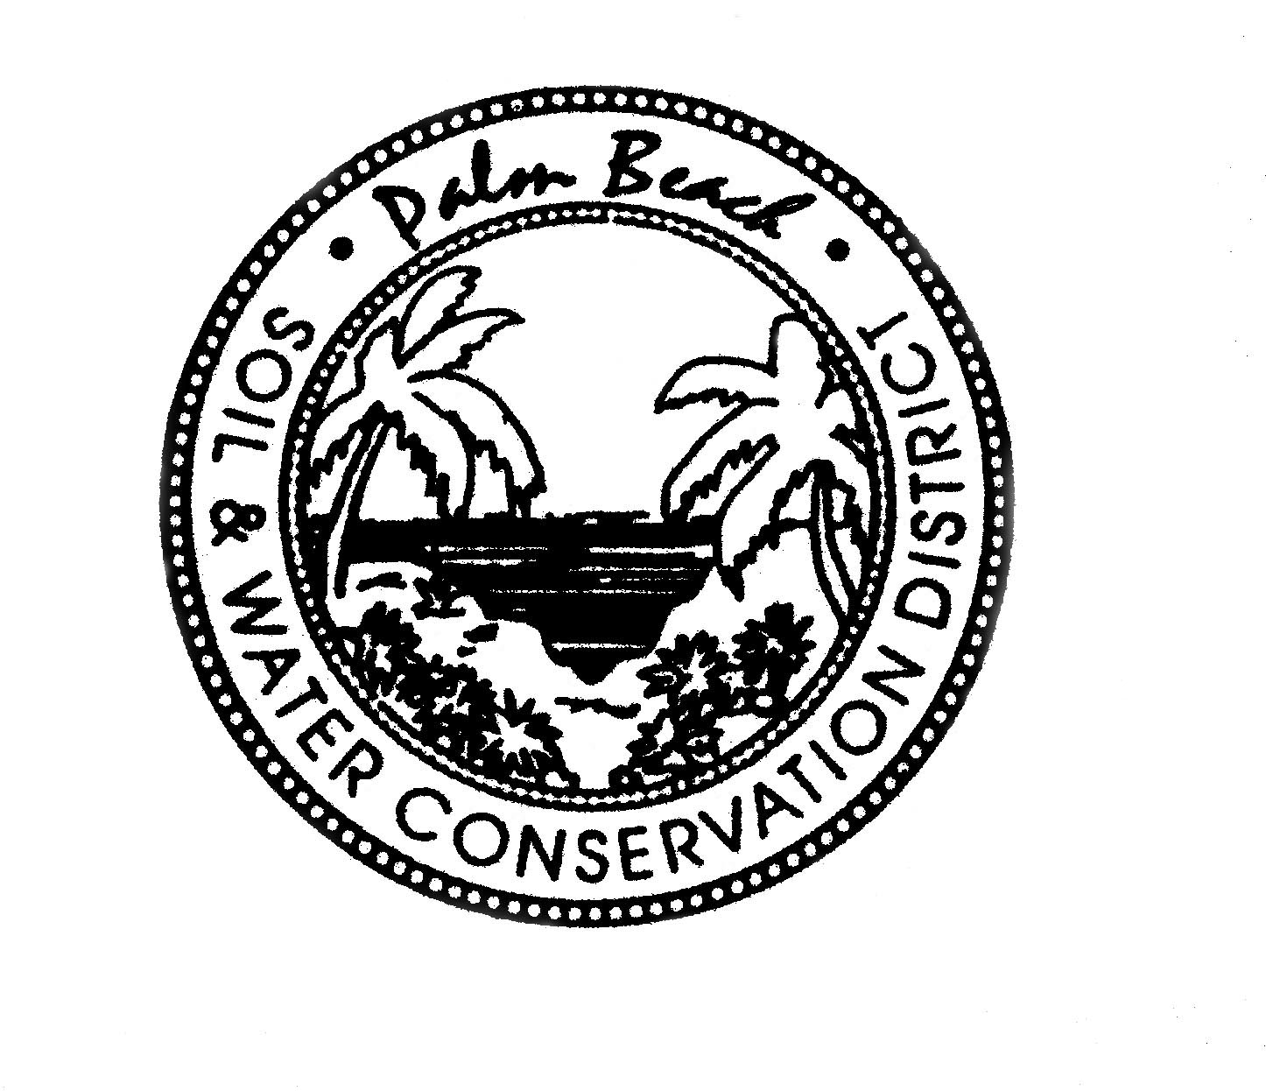

AGENDA

PALM BEACH SOIL & WATER CONSERVATION DISTRICT
BOARD OF GOVERNING SUPERVISORS MEETING
Vista Center 2300 N. Jog Road, WPB 33411
January 19, 2023 at 1:30 PM

Part of this meeting may be conducted as a video or teleconference in order to permit maximum participation of Board members (Section, 120.54(5)(b)2). The Board may take official action at this meeting on any item appearing on this agenda and on any item that is added to this agenda as a result of a change to the agenda approved by the presiding officer of the meeting pursuant to Section 120.525, Florida Statutes. The order of items appearing on the agenda is subject to change during the meeting and is at the discretion of the presiding officer.

1. CALL TO ORDER
A Roll Call
B Invocation
C Pledge of Allegiance

2. *AGENDA APPROVAL

3. OATH OF OFFICE

4. *ELECTION OF OFFICERS

5. OUTGOING BOARD PRESENTATION

6. SECRETARY’S REPORT
*Approval of the September Meeting Minutes

- TREASURER’S REPORT

- STAFF REPORTS
A David DeMaio
B Laura Bloom
C Rosa Reyes
D Robert Perez

- USDA/NRCS UPDATE

NEW BUSINESS
- *Fiscal Year Board Meeting Dates, Time and Location
- *Budget Revision Fiscal Year 2022/2023
- AFCD Annual Meeting

OLD BUSINESS

DISCUSSION ITEMS

PUBLIC COMMENTS

ADJOURNMENT
*DENOTES ACTION ITEM

